**Experiment Name:** Arithmetic, Relational, Logical, and String Operations in Java

**Objective:**

* Demonstrate the use of arithmetic, relational, logical operation.
* String operations in Java using user input.

**Introduction:**

Java provides a rich set of operators for performing arithmetic, relational, logical, and String operations. These operators can be used to manipulate primitive data types as well as objects. In this lab, we will explore the use of these operators by writing a program that takes user input and performs various operations on it.

**Methodology:**

The program was written in Java. The program prompts the user to enter two integer values and a String value. The program then performs various arithmetic, relational, logical, and String operations on the entered values and displays the results.

**Source Code:**

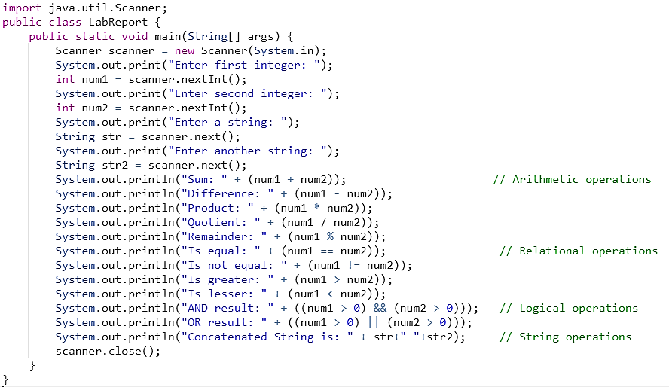

**Output:**

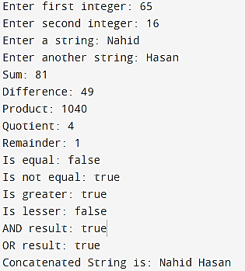

**Results:**

The program was successfully executed and the results of the various operations were displayed as expected.

**Discussion:**

The program demonstrates the use of arithmetic, relational, logical, and String operations in Java. These operations can be used to manipulate data in various ways. The use of user input makes the program more interactive and allows for more flexibility in testing different scenarios.

**Conclusion:**

This lab demonstrated the use of arithmetic, relational, logical, and String operations in Java using user input. The program was successfully executed and the results were as expected. This shows the versatility of Java in performing various operations on data.